**Lab Exercise 2 – Reconnaissance and Network Scanning Lab**

Due Date: February 3, 2023 11:59pm

Points Possible: 7 points

Name: Carlos F Revilla

*By submitting this assignment you are digitally signing the honor code, “On my honor, I pledge that I have neither given nor received help on this assignment.”*

**1. Overview**

This lab exercise will provide some hands-on experience with reconnaissance, network scanning, and service enumeration.

**2. Resources required**

This exercise requires a Kali Linux VM running in the Virginia Cyber Range.

**3. Initial Setup**

From your Virginia Cyber Range course, select the **Cyber Basics** environment. Click “start” to start your environment and “join” to get to your Linux desktop login.

**4. Tasks**

**Task 1: Whois lookups**

For this portion of the exercise, you can use a web browser on your laptop or desktop computer, or you can log in to your Cyber Basics environment in the Virginia Cyber Range.

***WHOIS*** is a tool for querying databases containing domain registration data to determine ownership, IP addresses, and other information. A reverse whois lookup can be used to find domains that are registered by a particular individual or organization. ICANN is the authoritative source for WHOIS information, however due to the General Data Protection Regulation (GDPR) a lot of its information is now restricted. Other sources of WHOIS information include <https://pk.godaddy.com/whois>, and <https://whois.domaintools.com/>.

*Question #1:* Do a whois lookup on the domain **jmu.edu**. To whom is the domain registered? What is the administrative contact name, address, email, and phone number? (.5 point)

Dennis Little

James Madison University

Director, Enterprise Infrastructure

Massanutten Hall 265

MSC 5733

Harrisonburg, VA 22807

USA

+1.5405681676

email@jmu.edu

**Task 2: nslookup and dig**

**Nslookup** is a Linux and Windows tool for querying the distributed database that makes up the domain name system (DNS). This database translates host names (such as www.virginiacyberrange.org) to IP addresses (99.86.229.9). This translation is necessary because your computer must have the IP address of systems, such as web servers, that it communicates with, but humans are not good at remembering strings of numbers so we remember hostnames instead. DNS converts hostnames to the proper IP address so your web browser can find that web page. This DNS lookup usually happens in the background so users don’t realize it is happening. You can use the nslookup tool to do this mapping from the command line.

For this exercise, you will log in to your Virginia Cyber Range account and select the Cyber Basics environment, then click “start” to start your environment and “join” to get to your Linux desktop login.

*Question #2:* Use **nslookup** to find the IP address for vt.edu. What is the IPv4 address? Provide a screen shot and explain where you found the answer. (.5 point)

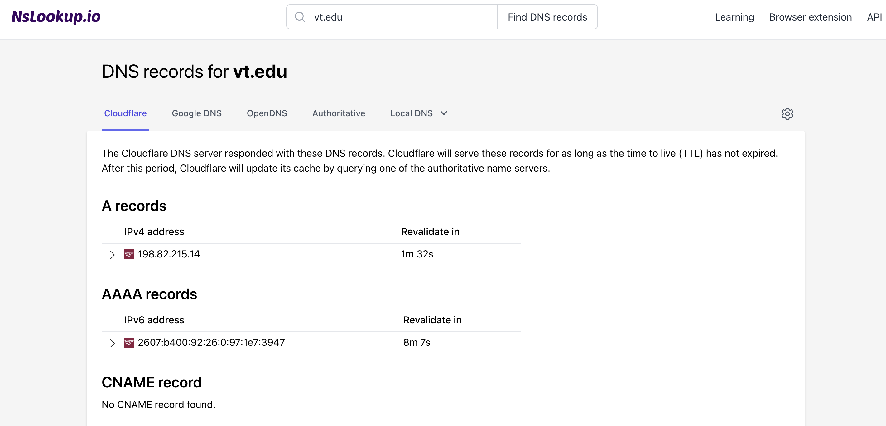

Answer found on NSlookup.io

Ipv4 adress: 198.82.215.14

**Dig** is another, and generally more powerful, tool for DNS database queries. However, dig is only available on Linux and Unix systems.

*Question #3:* Examine the Linux ‘man page’ for the dig utility to find more information about dig. What does the ‘**-x**’ command-line option do in dig? (.5 point)

-x in dig: Performs a reverse DNS lookup, converting an IP address to a hostname.

*Question #4:* Use dig to conduct a reverse lookup of the IP address 134.126.20.33. What is the hostname or hostnames correspond with that IP address? (.5 point)

cs.jmu.edu.

**Task 3: Network scanning using nmap**

Your Kali Linux virtual machine in the Virginia Cyber Range is connected to a small network subnet with other systems. Your first step in this exercise is to understand your network neighborhood.

*Question #5:* What is your IPv4 address and netmask? (.5 point)

Ipv4: 10.1.54.74

Netmask: 255.255.240.0

There are different ways to accomplish host discovery on a network. For this exercise we will use Nmap (<https://nmap.org/book/man.html>), a widely used tool for network exploration and port scanning. Nmap can be used to scan a single hostname or IP address or range of addresses. You can learn more about Nmap through the man page (**man nmap**) or simply type **nmap** with nothing else and hit enter to see a summary of command options and usage. To scan a single host you would use the following command:

**$ nmap <options> <hostname or IP address>**

*Question #6:* Run an nmap scan against your own IP address. What ports are open? (.5 point)

Starting Nmap 7.80 ( https://nmap.org ) at 2023-02-04 01:09 UTC

Nmap scan report for ip-10-1-54-74.ec2.internal (10.1.54.74)

Host is up (0.00014s latency).

Not shown: 998 closed ports

PORT STATE SERVICE

22/tcp open ssh

3389/tcp open ms-wbt-server

Nmap done: 1 IP address (1 host up) scanned in 0.08 seconds

**Ping scan**. Let’s see what other systems are on the network by using Nmap’s ping scan. Nmap has a ping scan option that simply sends a ping packet to each IP address and listens for replies to identify active hosts. For this scan you will scan your network using CIDR notation which looks like the following: **your_IP_address/CIDR**

You will replace **your_IP_address** with your actual IP that you identified in Question #5. The second part is to replace the **CIDR** with the actual CIDR notation for your network. Use your Google skills to find the CIDR notation of your network based on your netmask found in Question #5 and replace the word **CIDR** with it to scan the entire network where your system lives. Don’t forget to give nmap the **ping scan only** option!

*Question #7:* Which active IP addresses did you discover on the network? (1 point)

1: lo: <LOOPBACK,UP,LOWER_UP> mtu 65536 qdisc noqueue state UNKNOWN group default qlen 1000

link/loopback 00:00:00:00:00:00 brd 00:00:00:00:00:00

inet 127.0.0.1/8 scope host lo

valid_lft forever preferred_lft forever

inet6 ::1/128 scope host

valid_lft forever preferred_lft forever

2: eth0: <BROADCAST,MULTICAST,UP,LOWER_UP> mtu 9001 qdisc mq state UP group default qlen 1000

link/ether 0e:05:87:40:03:c7 brd ff:ff:ff:ff:ff:ff

inet 10.1.54.74/20 brd 10.1.63.255 scope global dynamic eth0

valid_lft 2642sec preferred_lft 2642sec

inet6 fe80::c05:87ff:fe40:3c7/64 scope link

valid_lft forever preferred_lft forever

**Port scan**. By default, **nmap** will conduct a port scan of the target address(es), trying to connect to ports 1 – 1000 for each IP address scanned and report which ports it finds open, or “listening”. Now that we have identified potential target systems we will scan them to identify open networking ports. Use **nmap** with *no options* to scan each host that you discovered in the step above.

*Question #8:* List each IP address that you scanned and the port numbers and services exposed on each system. (.5 point)

1: lo: <LOOPBACK,UP,LOWER_UP> mtu 65536 qdisc noqueue state UNKNOWN group default qlen 1000

link/loopback 00:00:00:00:00:00 brd 00:00:00:00:00:00

inet 127.0.0.1/8 scope host lo

valid_lft forever preferred_lft forever

inet6 ::1/128 scope host

valid_lft forever preferred_lft forever

2: eth0: <BROADCAST,MULTICAST,UP,LOWER_UP> mtu 9001 qdisc mq state UP group default qlen 1000

link/ether 0e:05:87:40:03:c7 brd ff:ff:ff:ff:ff:ff

inet 10.1.54.74/20 brd 10.1.63.255 scope global dynamic eth0

valid_lft 2642sec preferred_lft 2642sec

inet6 fe80::c05:87ff:fe40:3c7/64 scope link

valid_lft forever preferred_lft forever

*Question #9:* Which systems (IPs) are possibly running a web server? If any of your targets are running a web server, provide a screen shot of the main web page of the server. (.5 point)

1: lo: <LOOPBACK,UP,LOWER_UP> mtu 65536 qdisc noqueue state UNKNOWN group default qlen 1000

link/loopback 00:00:00:00:00:00 brd 00:00:00:00:00:00

inet 127.0.0.1/8 scope host lo

valid_lft forever preferred_lft forever

inet6 ::1/128 scope host

valid_lft forever preferred_lft forever

2: eth0: <BROADCAST,MULTICAST,UP,LOWER_UP> mtu 9001 qdisc mq state UP group default qlen 1000

link/ether 0e:05:87:40:03:c7 brd ff:ff:ff:ff:ff:ff

inet 10.1.54.74/20 brd 10.1.63.255 scope global dynamic eth0

valid_lft 2642sec preferred_lft 2642sec

inet6 fe80::c05:87ff:fe40:3c7/64 scope link

valid_lft forever preferred_lft forever

*Question #10:* **Version detection**. Now we need to look a little more to find out specifics about the open services you detected. Run an Nmap scan against each target that will perform version detection and show service versions. (there is more than one option that can do this) List all service versions that you find for each IP address. (1 point)

*Question #11:* Taking it one step further. Scanning is the first step to identify active targets, which we did in Question #7 and then to identify open ports and services, which we did in Question #8. By performing version detection like we did in Question #10 we can start to identify potential vulnerabilities. One of the targets you scanned has a File Transfer Protocol (FTP) server running, which is a vulnerable way to transfer files. The **nmap -A** scan can give you some really valuable information for logging into that FTP server. Exploit the anonymous FTP login and retrieve a file from the server and paste its contents here. (1 point)

*By submitting this assignment you are digitally signing the honor code, “I pledge that I have neither given nor received help on this assignment”.*

**END OF EXERCISE**

**References**

* <http://viewdns.info/>
* <https://nmap.org/book/man.html>
* <https://en.wikipedia.org/wiki/Port_(computer_networking)>
* <https://en.wikipedia.org/wiki/Classless_Inter-Domain_Routing>